EGR 326 Embedded System Design and Build Project

Specifications Document

Name1 and contact

Name 2 and contact

Professor ----

Date

**Purpose and Goals**

The goal of the final design project for EGR 326 is to ………………….. (include 2 -3 sentences referencing purpose, customer requirements, what processor you will use and supporting devices)

**High level Block Diagram**

Brief Description of each block- don’t use part numbers. Just reference parts- like proximity sense, real time clock, inputs (buttons), display, etc…

**UML diagram**

**Example UML:**

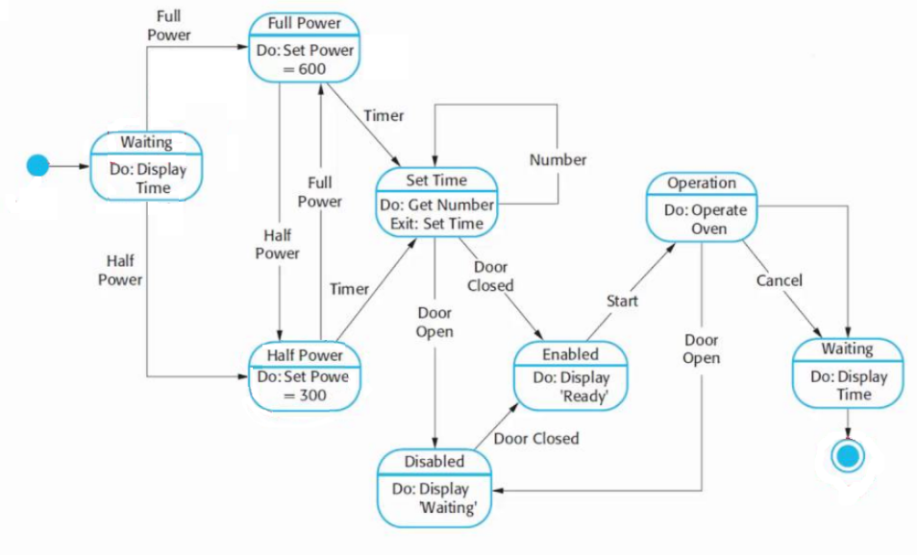

**User Interface**

Step –by Step description of each UML block and what triggers transfers to other blocks

* Description of system at startup
* Description of system when each user interface (visual or tactile) and how each interface responds to input
* Example: LCD will default to time if no input is received within 60 seconds.
* Describe system in every scenario you can think of- referencing chart above.
* Describe what triggers interrupts and the effects on the system
* Describe effects of temperature
* Describe all moving parts

**Requirements.**

* Numbered requirements using “must” for all requirements that you intend to include. Follow rules listed in lecture
* Include all “extra” requirements (and label as “extra”)
* Include requirements of all interfaces, (audio, visual, electrical)
* Include limitations (cost, size, distance detection…)
* Every requirement in your customer requirements document should be addressed.

Indicate which customer requirement your requirement links to. In the end, all customer requirements should be covered. (You may indicate at the end any customer requirements disregarded)

**Verification Plan**

This should contain the same number of entries as the customer requirements section.

Verification: **Was the system built right?**

Each numbered item should identify whether the corresponding requirement will be 1) tested, 2) inspected, 3) Analysis

* For each tested requirement, briefly identify how the requirement will be tested.

Project Timeline (sample)

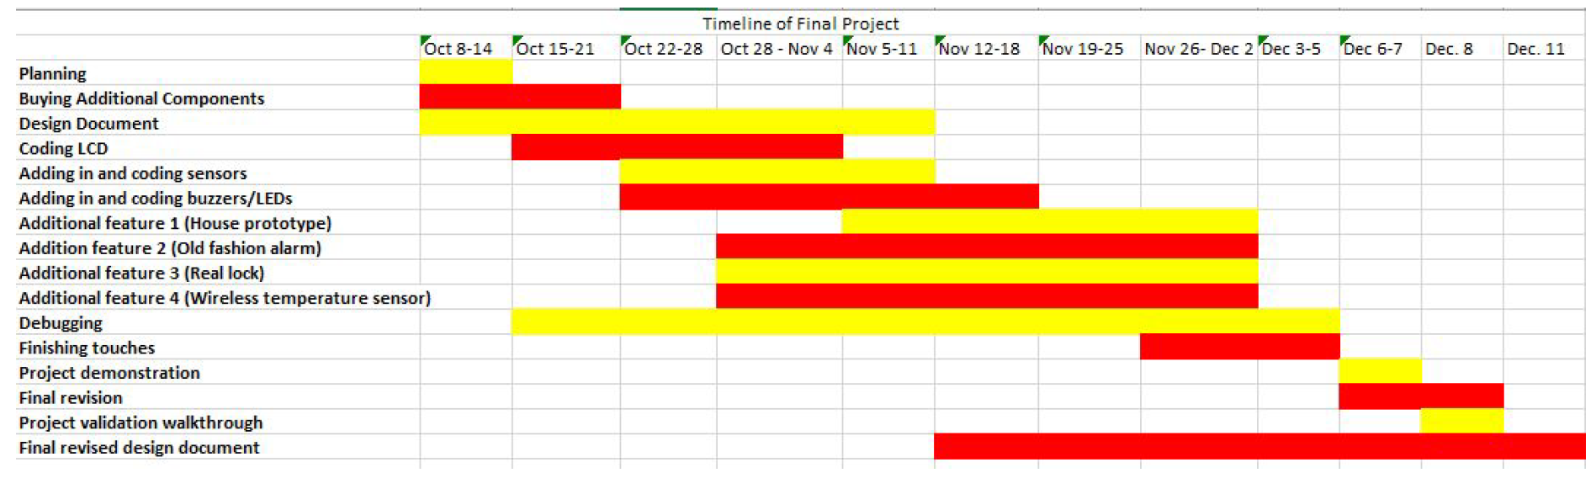

The final six “prelabs” are summarized as follows: (subject to change until the prelab is loaded in blackboard)

Prelab 7: Stepper motor and I2C

Prelab 8: Seven seg I2C display

Prelab 9: Hall effect sensor

Prelab 10: Saving data to EEPROM

Prelab 11: alternate stepper motor

Prelab 12: Watchdog reset